Water Access for Students Policy Brief
[Insert Graph of School Smart Source Data]
Example Below
Overview of Water Access in [Insert School District Name]
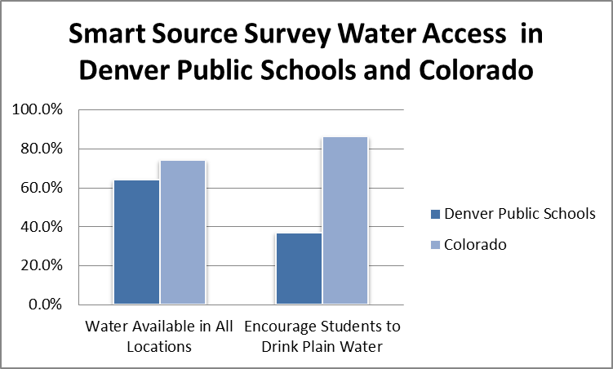
The Hunger-Free Kids Act requires schools to offer healthy beverages such as milk, water and 100% fruit juice to students at no charge. Despite the Healthy Hunger-Free Kids Act, free drinking water is not always immediately accessible to students. A national study revealed that between 2007-2008 only 12% of students attended school in a district with a wellness policy that included language regarding the availability of free drinking water [1].Reports indicate that the inadequate number, inconvenient location, and poor maintenance of drinking water outlets discourage students from using school drinking fountains[3].
Water Access during the School Day is Important
A recent study on 6-7 year old students revealed that “under conditions of mild dehydration, not resulting from exercise, intentional water deprivation or heat exposure, children's cognitive performance can be improved by having a drink of water [2].
Drinking water improves students’ ability to learn by improving their ability to focus and improving academic performance. Water also sustains overall health. Increased water consumption may prevent school-aged children from being overweight and may improve oral health [4]. Improved oral health is related to less absences from toothaches caused by cavities [4].
Issues with Existing Policies
Schools in [Insert County Name] and throughout Colorado are struggling to improve water access due to a variety of barriers and challenges. These include but may not be limited to:
- [Insert barriers and challenges your County schools are facing]
- Examples:
  - Insufficient funding for implementation and/or improve water access. There are limited funding opportunities to support initiatives and school districts lack resources to improve access within each and every school.
  - Very few schools have policies that prioritize free drinking water. Even when such policies exist, the language is often limited in scope [3].

What has Already Been Done
Nationally, states and school districts are working to include policies around water access during the school day.
- Massachusetts: In 2010 passed legislation requiring public schools to make no-cost, potable drinking water available to students during the school day [3].
- Pennsylvania: Hazelton School District, a wellness policy stipulates provision of water during meal periods and throughout the school day (see Appendix) [3].
- Mississippi: McComb School District wellness policy allows students to take water anywhere in the school and encourages teachers to drink only water outside of teachers’ lounges to be role models for the students [3].
Colorado also has many groups addressing water access:
- [Insert local schools/districts addressing water access]
- Examples:
  - Boulder: Boulder Valley School District has incorporated a water access policy into their district wellness policy (See Appendix).
  - Denver Metro: 8 schools within Denver Public Schools and Aurora Public Schools are implementing wellness policies to promote water access for students during the school day demonstrating that this is something that many schools take seriously and value.
Recommended Best Practices for Implementation at Denver Public Schools
Policies have the potential to significantly influence water consumption among children and adolescents since they spend a large portion of their time at school and the provision of filtered, cooled drinking water in school cafeterias, coupled with education and active promotion, may be an effective way to increase students’ water intake [3].
[Insert County wellness/ focus area quote] Example: “DPS is leading the nation in focusing this level of effort and attention around Whole Child supports because we know – and research shows – it will not only improve academic outcomes, but is critical to achieving our vision that Every Child Succeeds. In DPS, we are committed to providing equitable and inclusive environments where we ensure students are Healthy, Supported, Engaged, Challenged, Safe, and socially and emotionally intelligent” [6].
[Insert examples of how your school/ districts align with state or local focus] Example: Incorporating water into the districts wellness policy aligns with DPS’s vision that “every child succeeds”. Therefore, our recommendations for items to include in water access policies are:
- Include language for funding strategies within the provisions of a water access policy.
- Ensure drinking water is accessible to students throughout the school day and after school. Schools should implement evidence based strategies for promoting water to students, such as providing cups near water sources, installing bottle fillers; or providing chilled water[1].
- Include language about drinking water access in the district wellness policy.
- Include language about offering free drinking water during lunch periods and that water fountains are clean and functioning properly[5].
- Include language to allow students to bring water bottles into classrooms[5].
Other recommendations to consider when writing and implementing water access policies are detailed below.
Options Requiring Funds
- Consider installing drinking fountains in locations where students can easily access them including school cafeterias, gymnasiums, and throughout hallways.
- Implement drinking water testing and remediation programs.
Low Cost Options
- Offer non-fountain sources of water (e.g., dispensers, pitchers, coolers) in areas where drinking fountains are not feasible.
- Consider providing cups at drinking fountains and other non-fountain sources of water to encourage students to drink more water.
- Develop alternative means for providing appealing drinking water.
No Cost Options
- School nutrition regulation may be a key policy mechanism for implementing these water promotion activities [1].
- Promote water consumption by using marketing campaigns [5].
- Limit the availability of sugar-sweetened beverages that compete with and displace water consumption.
- Encourage school staff to model healthy behaviors, including water consumption and provide training for school administrators and staff to be able to do so.
- Offer support and/or guidance to schools seeking support for funding, implementation, and resources.
References
1. Model Wellness Policy Language for Water Access in Schools, N.P.L.A. Network and t.P.C. Obesity, Editors., ChangeLab Solutions.
2. B., E.C.J., Does having a drink help you think? 6-7-Year-old children show improvements in cognitive performance from baseline to test after having a drink of water. Appetite, 2009. 53(3): p. 469-472.
3. Anisha I. Patel, M., MSPH, MSHS, and Karla E. Hampton, JD, Encouraging Consumption of Water in School and Child Care Settings:Access, Challenges, and Strategies for Improvement. American Journal of Public Health, 2011. 101(8).
4. Foundation, D.D.o.C., Something to Smile About: A Toothkit to Improved Health. 2017.
5. Proposed Rule: Local School Wellness Policy Implementation Under the Healthy, Hunger-Free Kids Act of 2010. August 24, 2017 [cited 2018 November 20]; Available from: https://www.fns.usda.gov/school-meals/fr-022614.

